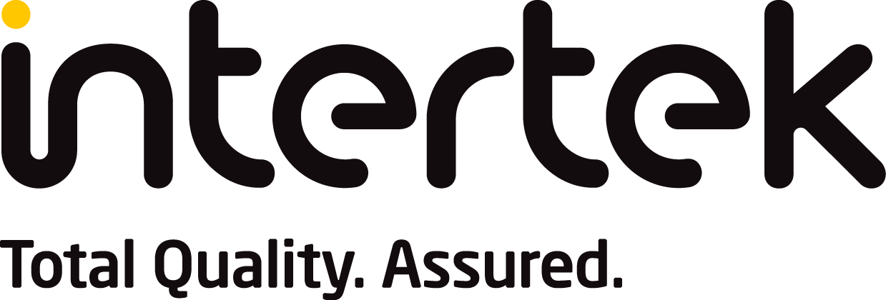
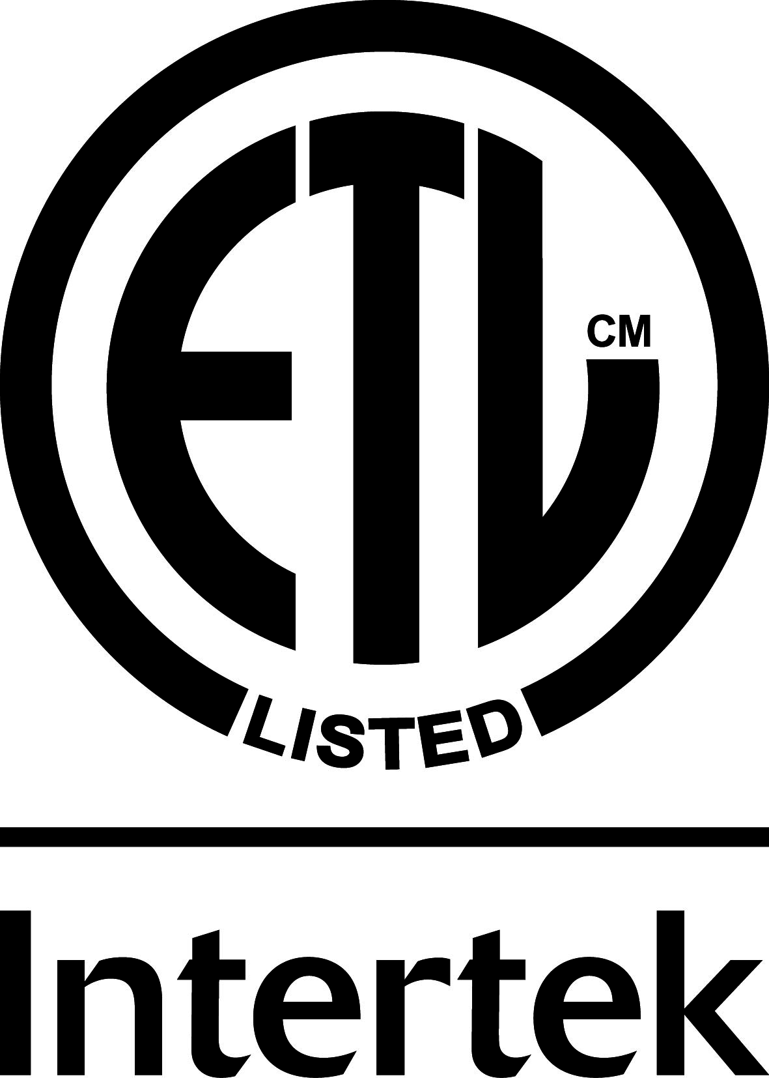

APPLICATION FORM

Central Station Listing & Certification

Please fill out a separate application for each site to be verified.
Fax completed application back to 330-405-3554, or email gary.flom@intertek.com

Company Name:
Contact Name:
Address 1:
Address 2:
City, State, Zip:
Phone:
Fax:
E-mail:
Government contract (International Traffic in Arms Regulation - ITAR), please circle one: yes no
Date application submitted:

Check each category as it relates to your business:
Currently a Listed Central Station through an NRTL?
⁫ Yes ⁫ No
If Yes by whom? ⁫ FM ⁫ UL ⁫ Other
If No – would you like Intertek to provide you with a proposal?
⁫ Yes ⁫ No
Monitoring the following installations:

⁫ Residential ⁫ Commercial ⁫ Proprietary ⁫ Government ⁫ Fire ⁫ Burglar ⁫ Banks ⁫ other
⁫ Employ qualified installation personnel? ⁫ Yes ⁫ No
⁫ Contract out installations? ⁫ Yes ⁫ No
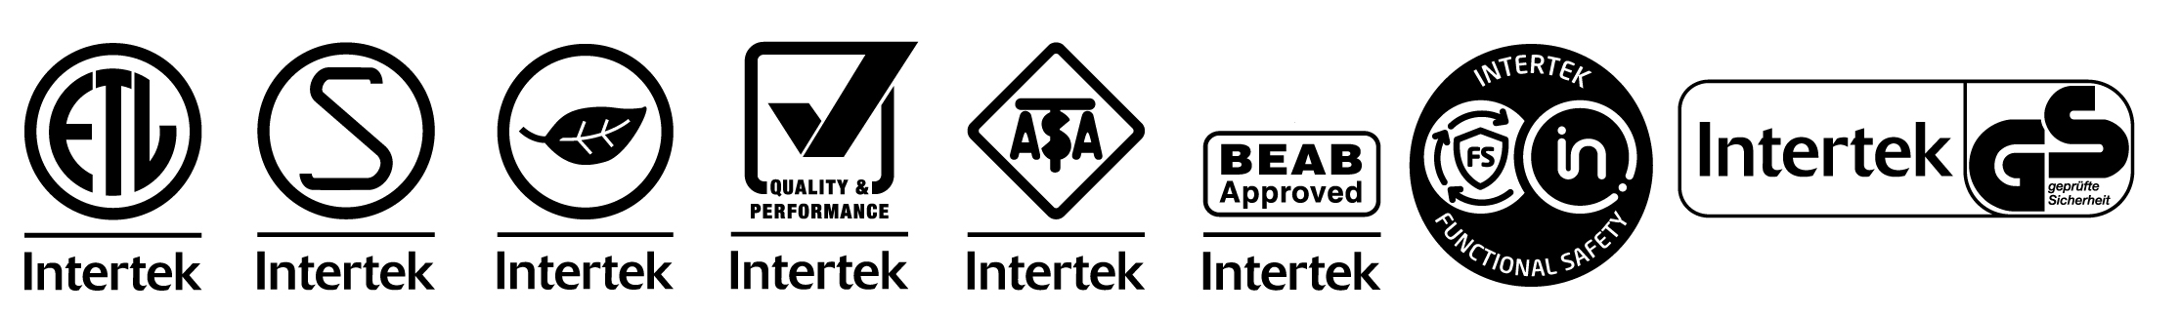
Central Station Application rev 2025.doc

